|  |  |  |  |  |
| --- | --- | --- | --- | --- |
| X | 3 | 5 | 7 | 9 |
| F(x) | 180 | 150 | 120 | 90 |

**Input:**

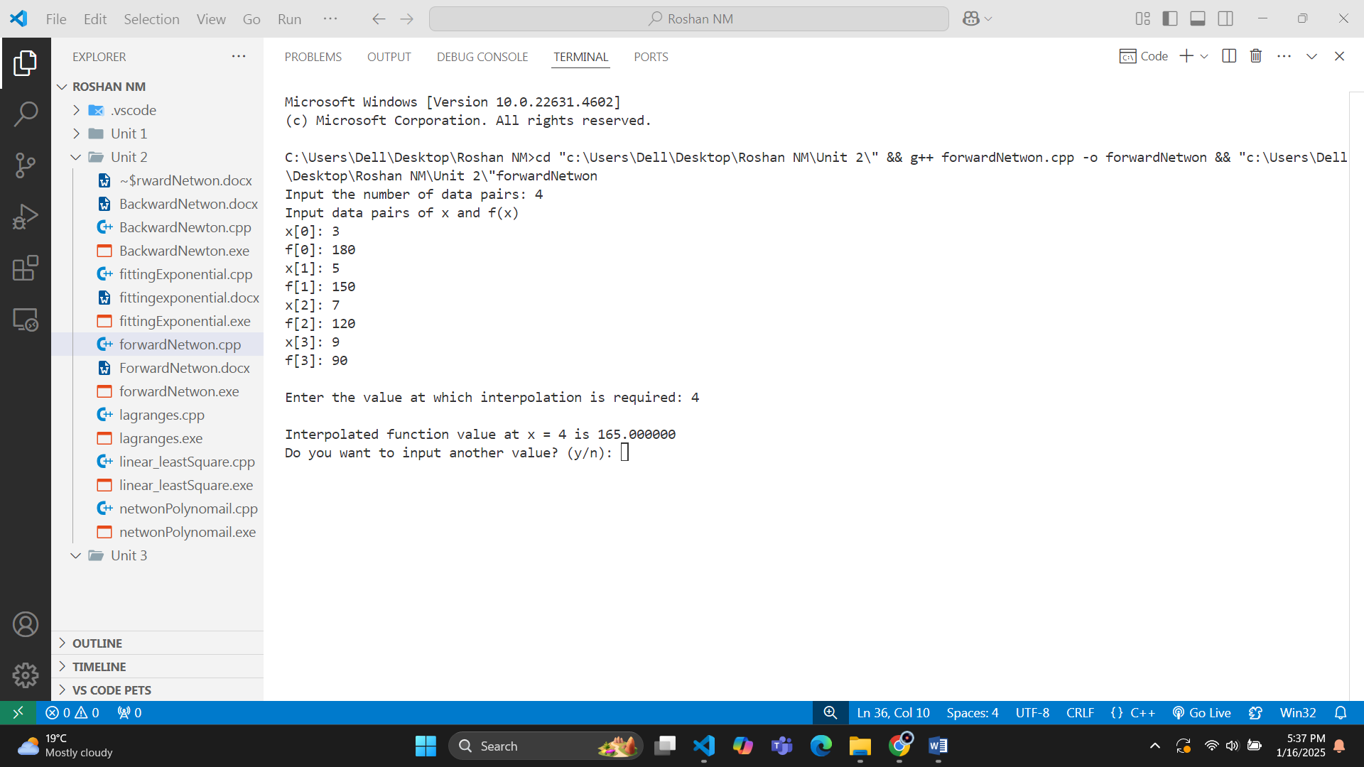**Output:**

|  |  |  |  |  |  |
| --- | --- | --- | --- | --- | --- |
| X | 1 | 2 | 3 | 4 | 5 |
| F(x) | 10 | 26 | 58 | 112 | 194 |

**Input:**

**Output:**

